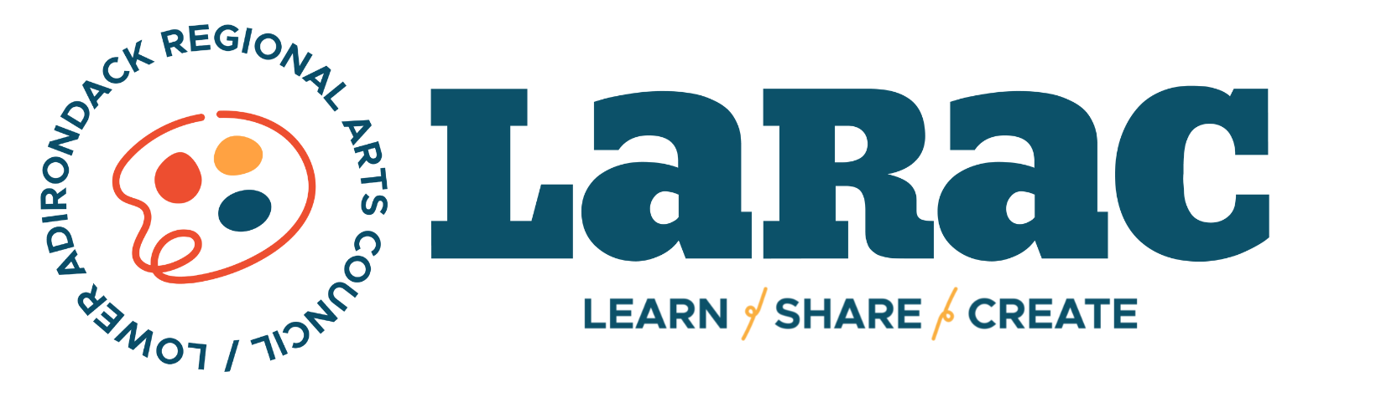

2024 INDIVIDUAL ARTISTS GUIDELINES

DEADLINE: DECEMBER 1ST, 2023

APPLICATIONS MUST BE HAND DELIVERED/MAILED TO:
Community Arts Grants, C/O LARAC, 7 Lapham Place, Glens Falls, NY 12801

LATE or EMAILED APPLICATIONS WILL NOT BE REVIEWED.

Funded by the New York State Council on the Arts, a state agency Statewide Community Regrants Program with the support of the Office of the Governor and the New York State Legislature; administered by the Lower Adirondack Regional Arts Council.

ALL APPLICANTS MUST ATTEND one free application seminar -or- set up a meeting with the Grant Coordinator.

ABOUT THE STATEWIDE COMMUNITY REGRANTS PROGRAM
The Statewide Community Regrants Program (formerly known as DEC) is available in Warren and Washington County through a competitive re-grant program administered by the Lower Adirondack Regional Arts Council (LARAC). Funds are provided on a statewide basis through the New York State Council on the Arts (NYSCA)- Statewide Community Regrants Program to fund public arts experiences and foster creative communities.

PURPOSE
New York State Council on the Arts (NYSCA) provides state funding to arts and cultural organizations. The Statewide Community Regrants program (SCR) was established in 1977 to reach out to communities that might not otherwise be able to access state funds. Local arts agencies, like LARAC, administer the SCR program on a local level to make arts support available to geographically, economically, and ethnically diverse populations to increase the vitality of and livability in local communities & neighborhoods in every county.

LOCAL HISTORY
The SCR Program was developed by the NYSCA in response to a 1974 mandate by the New York State Legislature to encourage greater local involvement in funding decisions affecting local organizations offering cultural services and programs. The SCR concept was adopted and implemented in a pilot program by NYSCA in 1977. Warren County was added as an additional site in 1978. In 2000, LARAC added administration of the Washington County grant program.

ABOUT CAG FOR INDIVIDUAL ARTISTS
Individual Artist Grants will be offered in the amount of $2,500 per commission.
+ The work must be artist initiated and reflect the social, ethnic, or geographic environment of Warren or Washington County’s community life or culture and/or engage local communities in the work of the artist. These projects are viewed as ways for artists to lead and direct the creative process in their communities and to showcase the artist as a community resource.
+ Applications in all artistic disciplines (visual arts, film, theater, dance, music, media, literature, folk art, and video etc.) are accepted and will compete within the same funding pool.

ELIGIBLITY for INDIVIDUAL ARTISTS
+ New Applicants MUST attend a Grant Applicant Informational Seminar or schedule a 1 on 1 meeting with the Grant Coordinator prior to applying.
+ All applicants must be at least 18 years of age.
+ Primary residence must be located in Warren or Washington County (proof of residence required, i.e., driver’s license, voter registration form, tax bill)
+ Proposed project must take place in the same county as the applicant’s legal address.
+ Proposed project must engage a segment of the community through a public program, such as an exhibition or performance that is open to the public, and/or the inclusion of community involvement in the development and creative process of the artists’ project.
+ Submitted resume must demonstrate qualifications to undertake the proposed project.

USE OF FISCAL SPONSORS
An individual artist or collective may apply for decentralization funds through a fiscal sponsor. The entity serving as the fiscal sponsor becomes the “applicant organization” and must meet the same eligibility requirements as an applicant organization.

Fiscal Sponsors are responsible for:
- Knowledge and understanding of grant opportunity criteria and relevant guidelines.
- Ensure work will occur within the appropriate contract period and required service area.
- Consulting with the sponsored group/artist regarding project eligibility and conveying all relevant grant application information, including deadlines.
- Registering requests and submitting applications with all required supporting information.
- Execute a letter of agreement with the sponsored group/artist that clearly outlines the administration of the grant and defines mutual responsibilities.
- Informing the sponsored group/artist of funding decisions in a timely manner (prior to the expiration of the appeals period).
- Receiving and disbursing granted funds and ensuring that all relevant tax filings and reporting are executed as appropriate.
- Submitting a final report on the expenditure of the grant funds.

Please Note: Direct NYSCA applicants may not serve as a fiscal sponsor for a DEC applicant.

WHO’S NOT ELIGIBLE TO APPLY?
+ Artists who received an Individual Artist Grant in 2023.
+ Members of LARAC Board of Directors, Staff, or the Advisory Board.
+ Printing and publishing costs of already created work are ineligible.
+ Proposed project should be the creative work of one artist. While some projects may require the assistance of other artists, the creative efforts in the execution of the final project should be minimal.
+ Operating expenses of privately owned facilities, capital, or equipment purchases.
+ Workshop type projects are best suited to funding through organizational grants, not the Individual Artist Tier (contact the Grant Coordinator for specifics)

Funding through the Community Arts Grants program is a competitive process. Previous funding does not imply continued support; each application is reviewed anew in the context of current policies and applications. Funding is available for projects in all artistic and cultural disciplines.

FUNDING CRITERIA FOR THE REVIEW PANEL
+ Projects must be the creation of NEW WORK, not a continuation of previously started projects.
+ The work must be artist initiated and reflect Warren or Washington County community life, culture and/or engage local communities in the work of the artist. The community component is REQUIRED but is purposely broad to allow interpretation by the artist.
+ Project must engage a segment of the community through a public program or inclusion in the creative process (in person or virtually).
+ Project must be arts or culture-based.

2024 FUNDING PRIORITIES
- Provide accessible, quality art programming to all residents in our region
- Programs from new/up-and-coming community organizations
- Programs that are innovative and reflect the diverse art forms currently present in our region
- Programs that reflect the geographic area and culture of Warren or Washington County

WORK SAMPLES REQUIRED
FOR ARTISTS WORKING IN VISUAL FORMATS
+ Send 5-8 images (recommend work no older than 3 years) Images must be jpeg. Clearly label with your name.
+ Include a list of the following for each piece: title, medium, dimensions, and date of work.

FOR ARTISTS WORKING WITHIN PERFORMING AREAS
+ Send a maximum sample of 6 minutes of your work clearly labeled with your name and include a sheet listing the title of piece or pieces, length of full piece, and date of work.

FOR DIRECTORIAL PROJECTS, SEND 1 OF THE FOLLOWING
+ Up to 8 pages of a script with a maximum of 3 pages of directorial notes;
+ 5-7 minutes of past work with a maximum of 3 pages of written directorial notes or voiceovers of directorial notes.

LITERATURE SAMPLES CAN BE ANY COMBINATION OF POETRY ESSAY, OR PROSE
+ Send no more than 8 pages total, (if poetry, maximum of 1 poem per page), work should be labeled with artist’s name, titles of work, and date of work.

FOR OTHER MEDIUMS, PLEASE CALL THE GRANT COORDINATOR FOR DIRECTION ON SAMPLES

PREVIEW DEADLINE

Applications that are submitted by NOVEMBER 1ST, 2023 will be reviewed by the grant coordinator. Suggestions in the way of corrections, deletions or additional information needed, will be made, and the application will be returned to give the applicant a chance to make any changes necessary.

Applications submitted after the Preview Deadline will be considered final, and will not be given the opportunity for corrections, changes, or supplemental info additions.

*Changes made following a suggestion during the preview review process do not guarantee funding.

REVIEW PROCESS
+ A Review Panel made up of five community members from each county meet to review and discuss the applications based on specific funding criteria, and then recommend funding levels for approved projects.
+ In addition to the items sent with the application, Panel Members have access to program audits, Final Reports, and Grant Compliance Reports.
+ The LARAC Board of Directors has full authority for final approval based on the Review panels’ recommendations.

RESPONSIBILITES (IF FUNDED)
+ Keep the Grant Coordinator informed of any change regarding the funded project.
+ File Final reports by the due date written in the contract.
+ Use proper credit statement on all publicity and programs in acknowledging the support of NYSCA’s Statewide Community Regrant Program. (Required credit statements can be found online or sent by the Grant Coordinator at your request).
+ Two complimentary tickets to program, if applicable.

Alyssa Shiel, Grants Coordinator
GUIDELINES/APPLICATION/SEMINAR DATES: www.LARAC.org
QUESTIONS: outreach@larac.org or 518.798.1144 x4

