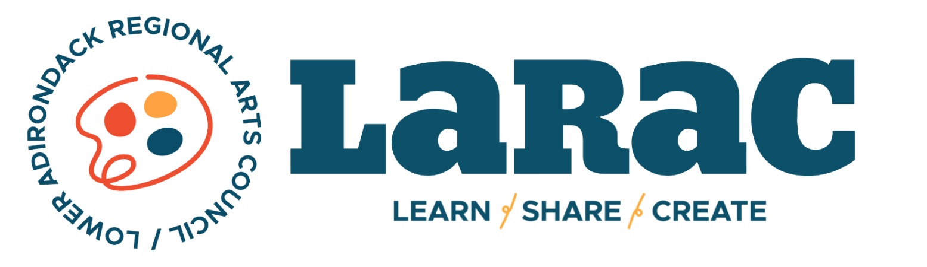

2024 INDIVIDUAL ARTISTS APPLICATION

DEADLINE: December 1st, 2023

Funded by the New York State Council on the Arts, a state agency Statewide Community Regrant Program with the support of the Office of the Governor and the New York State Legislature; administered by the Lower Adirondack Regional Arts Council.

APPLICATIONS MUST BE HAND DELIVERED/MAILED TO:
Community Arts Grants, C/O LARAC, 7 Lapham Place, Glens Falls, NY 12801

LATE or EMAILED APPLICATIONS WILL NOT BE REVIEWED.
.

A COMPLETE APPLICATION MUST INCLUDE:
- 1 Original, Signed Application
- 1 Copy of the Artists’ Resume as related specifically to the area in which the artist is applying
- 1 Letter from the presentation site(s) or organization(s) confirming their participation in the event (if applicable)
- 1 Copy of Proof of Primary Residence
- Work Samples - see guidelines for instruction

A COMPLETE APPLICATION MUST ALSO INCLUDE:
+ 5 Copies of Signed Application
+ 5 Copies of Artistic Resumes
+ 5 Copies of Artistic Support Materials

APPLICANT INFORMATION
Legal Name:
Applicant Mailing Address:
City: |  | State: |  |  | Zip: |  | County:
Phone Number:
Email: |  |  |  |  | Website:
Have you applied to LARAC as an Individual Artist for funding in the past 3 years?

PROJECT INFORMATION
Project Title:
Project Start Date: |  |  |  | Project End Date:
Total Project Expenses: |  |  |  | Amount Requested:
Community Involvement - In Person or Virtual
Summarize your project in a clear and concise statement:

CHECK THE DISCIPLINE THT BEST DESCRIBES THE PROJECT
Crafts | Dance |  | Folk Arts |  |  | Humanities |  | Literature
Media | Musical Theater |  | Music |  |  | Opera |  | Multi-Disciplinary
Visual Arts | Theater |  | Photography |  |  | Other (describe):
PROJECT DESCRIPTION
Clearly describe the NEW WORK you will create.
State your artistic vision for the final project. Be specific, provide details.
A community component is required for funding. Describe the way in which your project will reflect Warren or Washington County’s social, ethnic, geographic environment, or culture, and/or how you plan to involve the community:

Collaborating with groups and organizations can be a valuable component of your proposal. If applicable, name any individuals or organizations you plan to involve:

Provide a timeline for the project from beginning to end and give specific dates/locations when possible:

The final phase of your project must be open to the public. Where will it take place? What is your plan for marketing your final performance or exhibition? Be specific.

2024 Project Budget (round off to nearest dollar)

YOUR GRANT REQUEST MUST BE $2,500
A budget is requested so that the review panel understands the expenses that the proposed project entails.

In addition to artistic fees, funding requests may include materials, in-state travel and transportation, marketing fees, and other professional fees. The budget may not include capital expenses (for example- no equipment purchases or costs not directly associated with the proposal.)

EXPENSES |  | INCOME
 |  | (if project expense is over $2,500)
Your Fee: | $
Other professional services: |  | Income (donations or grants, specify):
Print Marketing | $ |  | $
Digital Marketing | $ |  | $
Transportation/Travel | $ |  | $
Space Rental | $ |  | $
Supplies (Specify):
 | $
 | $ | Income Total: | $
 | $ | Expenses Total: | $
 | $
 | $
Other (Specify):
 | $
 | $

CERTIFICATION
The person signing below must be the artists applying for the grant.
I, the undersigned, certify that all information contained in this application is true, I have read the guidelines of the Individual Artist Grant and certify that this application complies with, and is made subject to said guidelines, I release the Lower Adirondack Regional Arts Council, their employees and agents with respect to damage to property or materials submitted with this application, and I will be responsible for providing the services outlined herein as well as all reports and stipulations required of all Arts Initiative Individual Artist grantees.

Name (print or type):

Signature:

Title:

Date:

EMAIL QUESTIONS TO:
Alyssa Shiel, Grants Coordinator
Outreach@larac.org

